**Chess board:**

1. **Task Description**

Develop a "Chess" board game with redux when one with white other is black color of squre while clicking on white one color change to yellow and black to red.

1. **Task Output Screenshot**

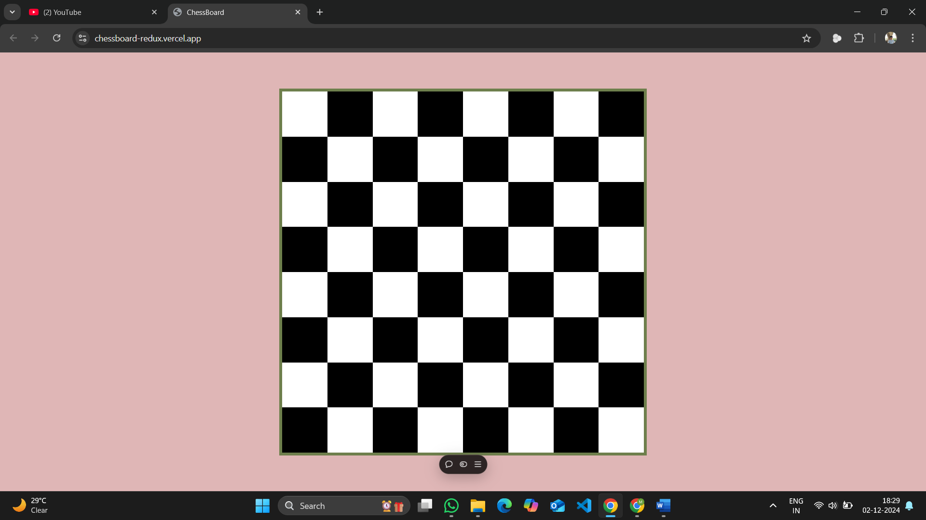

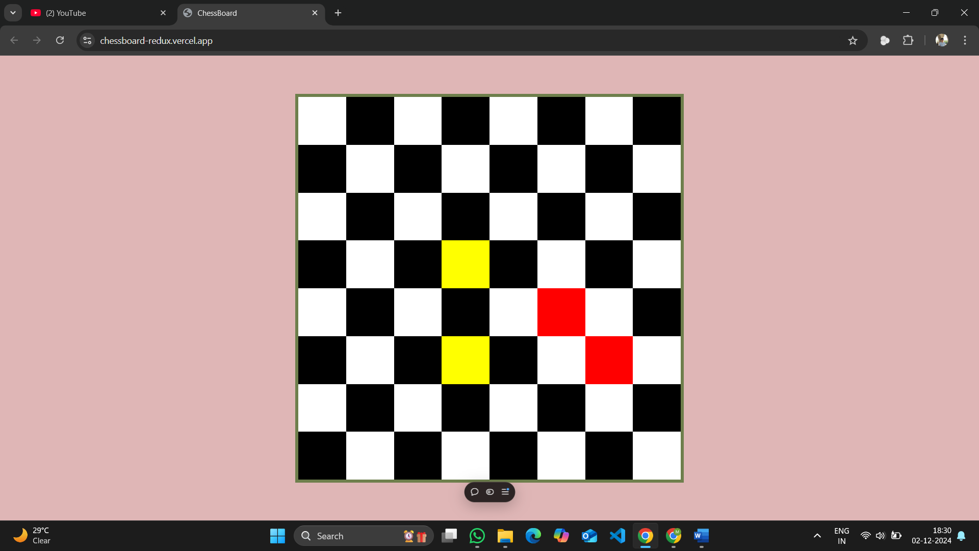

1. **Widget/Algorithm Used In Task**

* **Dynamic Chessboard**: The board is an 8x8 grid where each tile can be interacted with.
* **Color Changing Mechanism:** Each tile has an initial color. When clicked, it toggles between several colors (white, yellow, red, black).
* **State Management**: The state is managed using Redux, with each tile's state stored in the global Redux store.
* **Reusable Components**: The board and individual tiles are reusable components, making it easy to modify or extend the project.
* **React:** A JavaScript library for building user interfaces.
* **Redux Toolkit**: A toolset for efficiently managing application state in React apps.
* **CSS :**For styling the components and chessboard layout.

**Site is deployed live on** <https://chessboard-redux.vercel.app/>